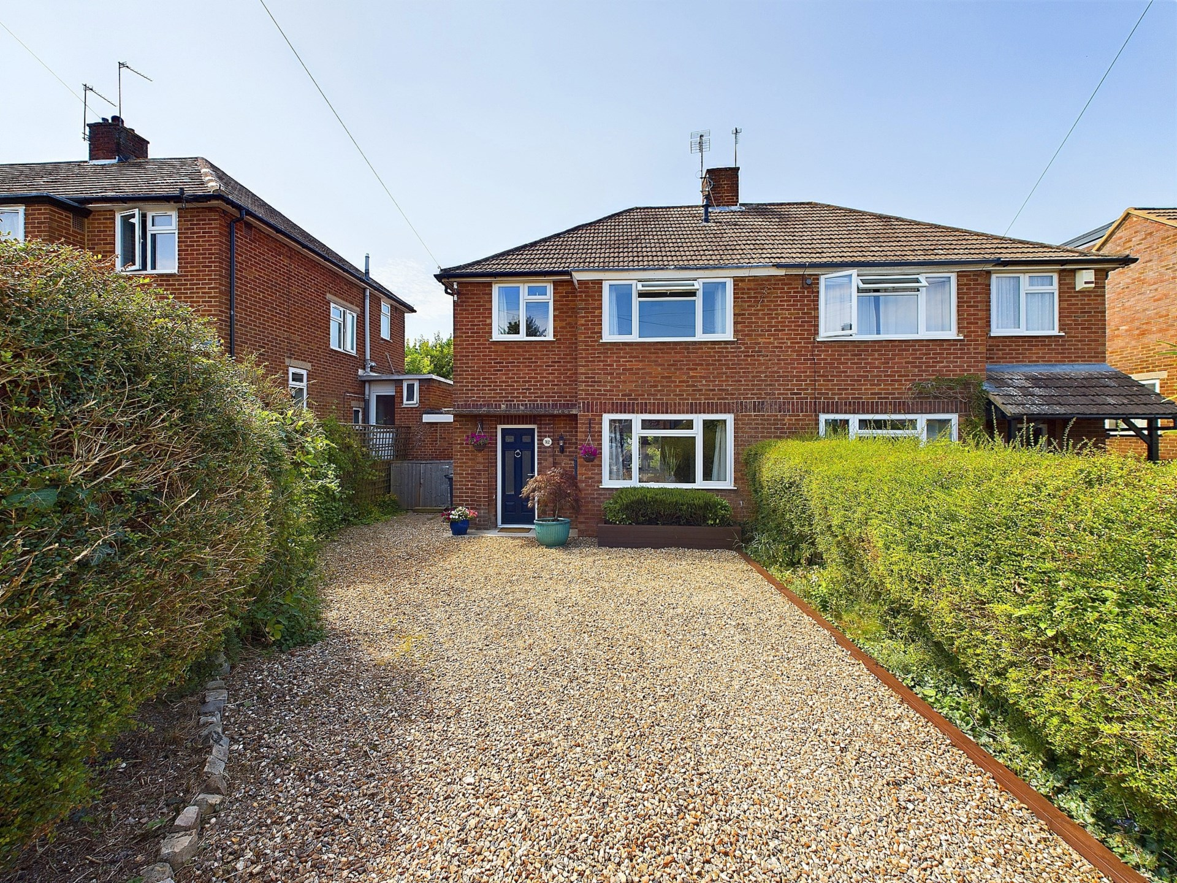bb-logo-final

Clifford Road

Princes Risborough

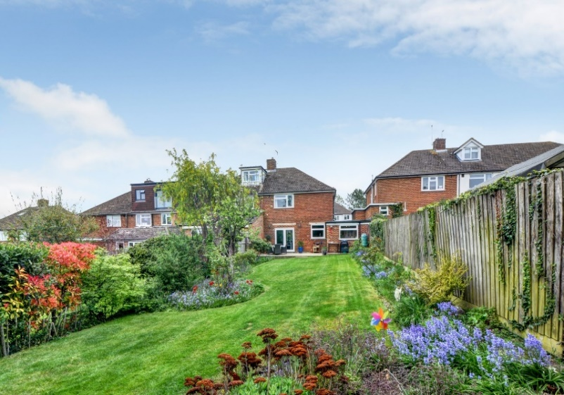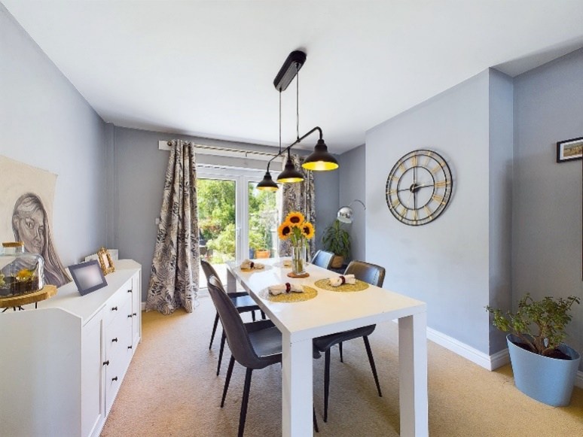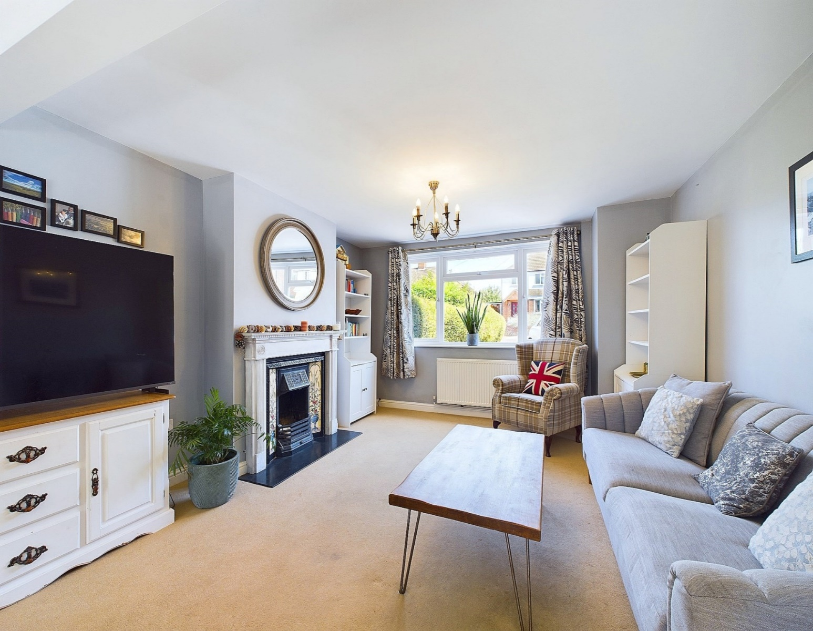

Clifford Road,

Princes Risborough,

Buckinghamshire,

HP27 0DU

OIEO - £525,000

Located at the edge of Princes Risborough, this beautiful three-bedroom semi-detached family home enjoys a peaceful elevated position, with views across Risborough and the surrounding woodlands/fields. Perfect for walkers and cyclists, you have immediate access to open countryside and the Ridgeway National Trail and Circular Walk.

The property is also conveniently located within walking distance of the local high street, school and mainline train station linking directly to London, Marylebone. This home is well-presented throughout and offers spacious living accommodation.

The ground floor includes an entrance hallway with storage cupboards, a superb open plan living room / diner with feature fireplace and French doors leading out to the delightful south west facing sunny garden, perfect for alfresco dining in the summer months.

There is also a good sized, modern separate kitchen as well as a breakfast room, also with French doors to the rear, which is currently being used as a home office, perfect for any purchasers looking to work from home.

Upstairs you will find two good sized double bedrooms, the main bedroom benefiting from fitted wardrobes, a further single bedroom as well as a modern family bathroom with bath and overhead shower.

To the front, there is a gravelled driveway with parking for two vehicles, bike storage, as well as on street parking if required.

Other notable features include, mains gas central heating system, double glazed windows, fully boarded loft with pull down ladder and lighting. Additionally, there is power connected in the garden for anyone wishing to build a home office in the garden.

Princes Risborough

The attractive market town of Princes Risborough offers a post office, a leisure centre and a good range of local shops including a Tesco, Marks & Spencer Simply Food and Costa Coffee. Further, more comprehensive leisure and shopping facilities can be found in High Wycombe, Aylesbury and Oxford all within easy reach. Excellent schooling is provided locally with a good choice of private and state schools close by including grammar schools in High Wycombe and Aylesbury.

There is access to the M40 motorway for London and the Midlands just 6 miles away (J6) and Princes Risborough station offers an excellent main line rail service to London (Marylebone - 35 minutes) and the Midlands.

EPC RATING – D

COUNCIL TAX BAND - D

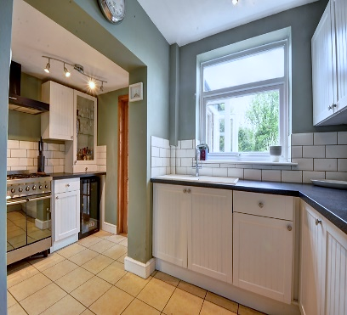

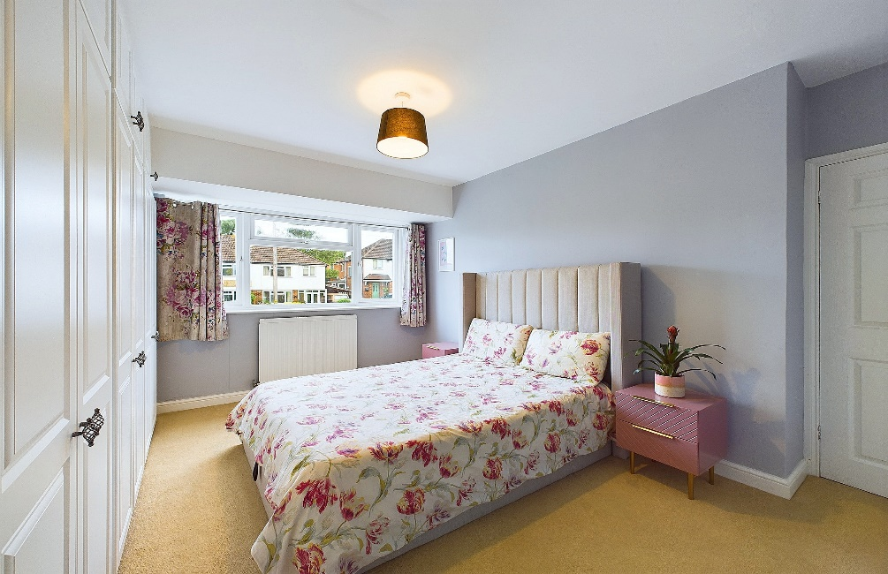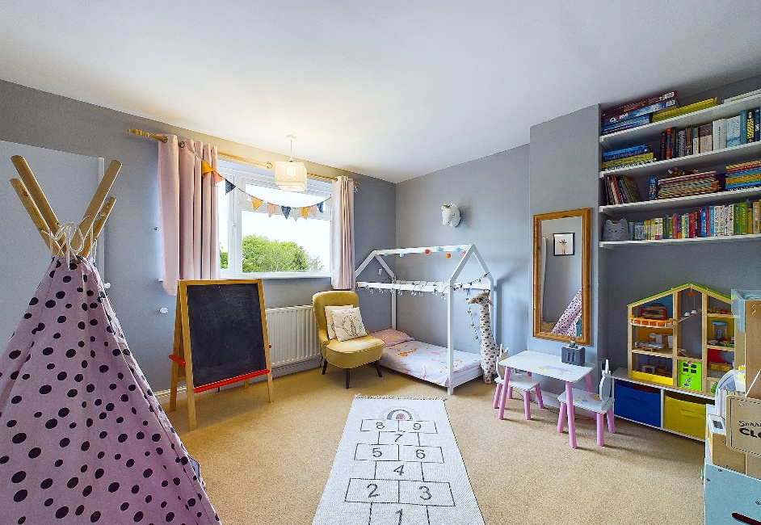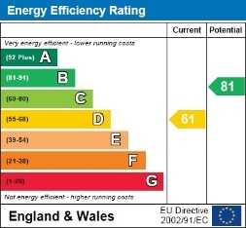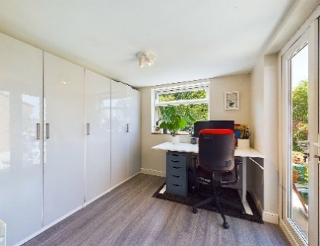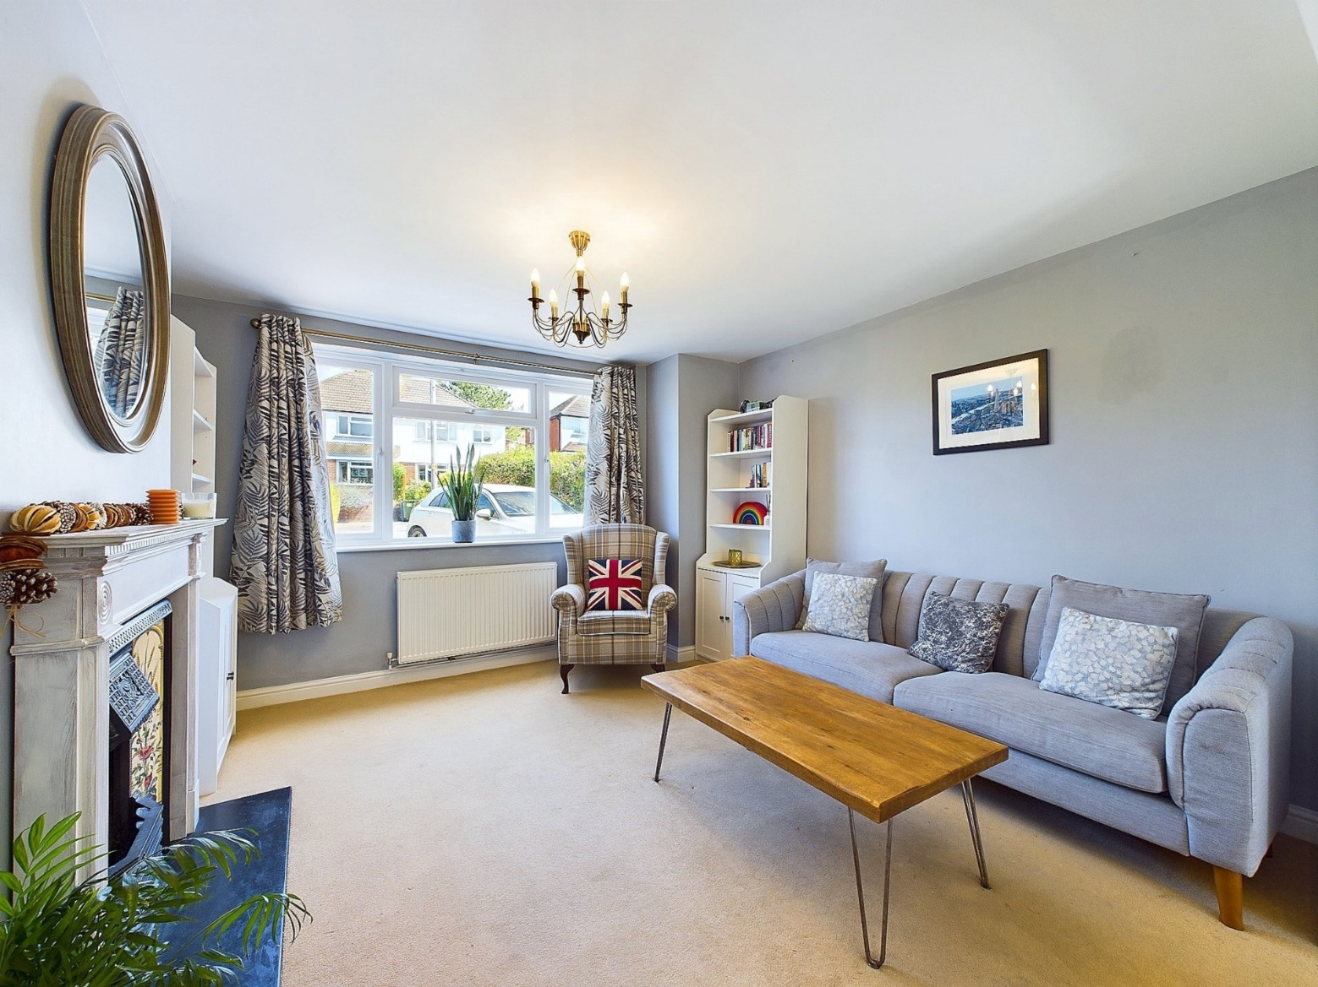

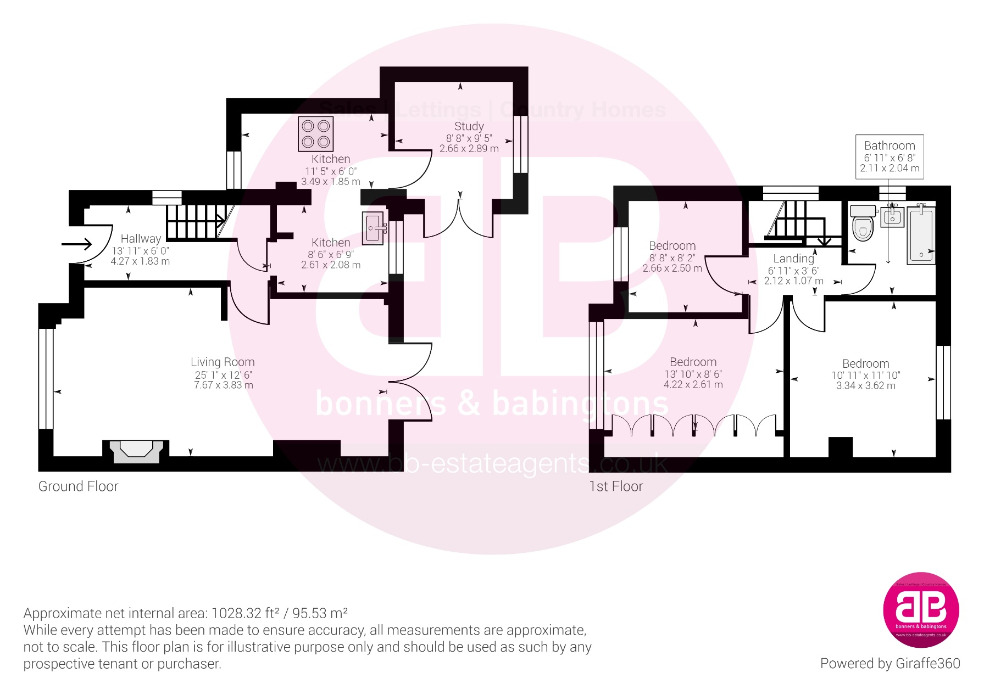

Zoopla LogoNAEA Propertymark Protected CMYKRM_Logo_NoStrap_Colourfacebook logoPrimelocation lscape

**Disclaimer**

We endeavour to make our particulars accurate and reliable. They are for guidance only and are intended to give a fair overall summary of the property. They do not form part of any contract or offer, and should not be relied upon as a statement or representation of fact. Measurements, areas and distances are approximate and photographs provided for guidance only. No undertaking is given as to the structural condition of the property, or any necessary consents, or the operating ability or efficiency of any service, system or appliance. Prospective purchasers must satisfy themselves with regard to each of these points. If there is any particular aspect of the property about which you would like further information, please contact us, especially, before you travel to the property. B2170

78 High Street, Princes Risborough, Buckinghamshire, HP27 0AX

01844 343661

www.bb-estateagents.co.uk