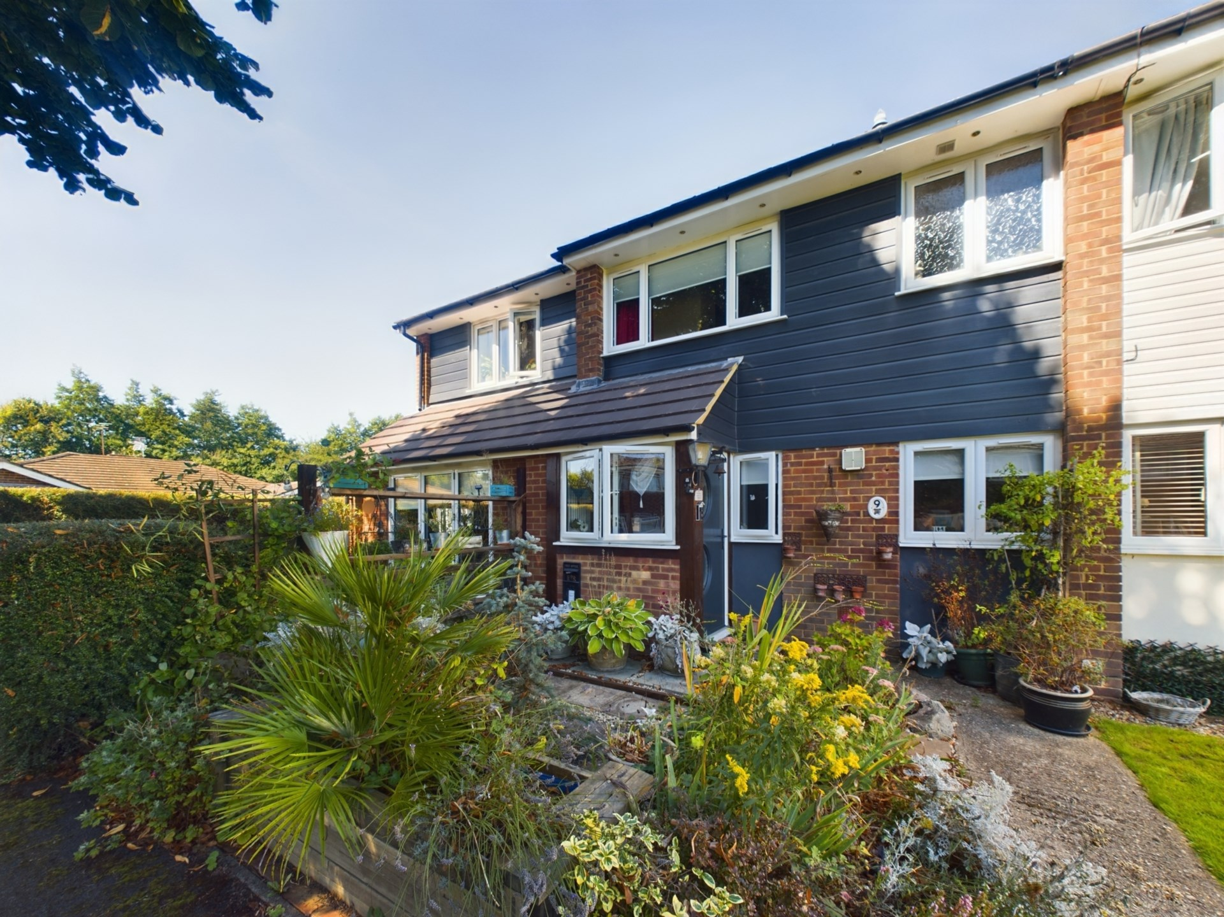



Marcourt Road

Stokenchurch

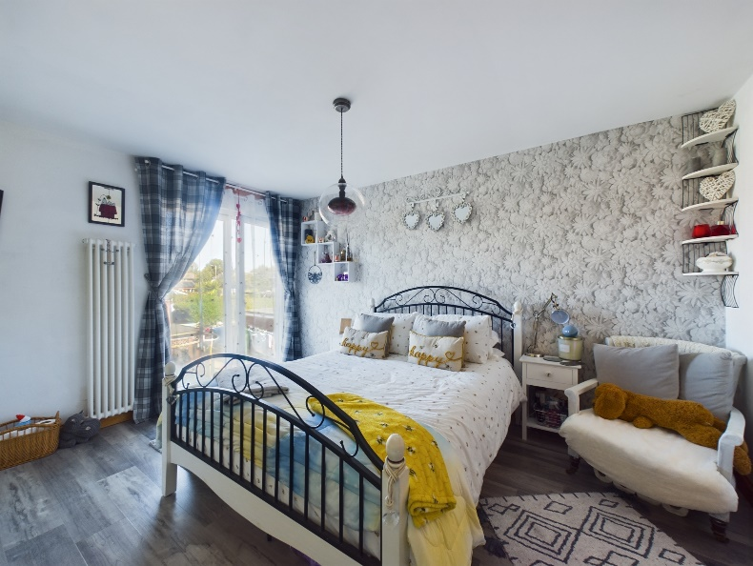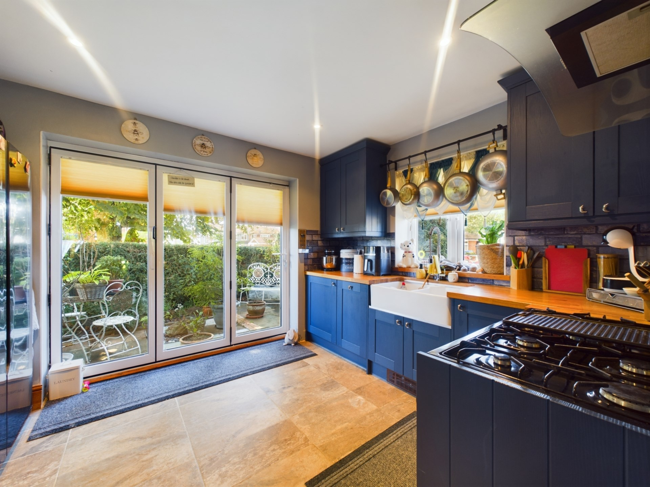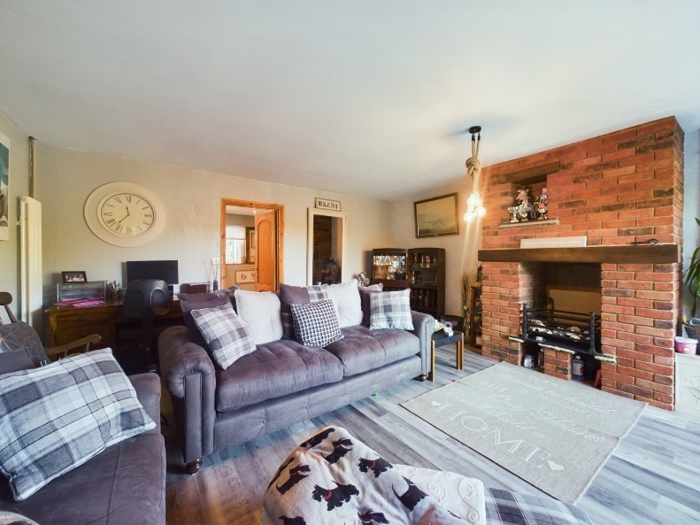

Marcourt Road, Stokenchurch,

HP14 3QX

Guide Price £500,000

A superb 4 double bedroom home offering versatile living space situated on a corner plot in a no through road in the sought-after village of Stokenchurch.

The accommodation briefly comprises entrance porch, living room with feature fireplace and bifold doors to the rear, family room with fireplace, dining room, fitted kitchen with integrated appliances with bifold doors to the front to the private entertaining area, good size utility room and cloakroom. On the first floor the landing gives access to the principle bedroom with dressing room, 'Jack & Gill' bathroom vaulted ceiling and Juliet balcony, the second bedroom also benefits from the 'Jack & Gill' bathroom, vaulted ceiling and Juliet balcony, there are two further double bedrooms and shower room. Outside the corner plot garden enjoys a good degree of privacy with paved terrace ideal for Alfresco dining, to the front there is an enclosed entertaining area accessed off the kitchen. There is a off road parking to the rear and a detached garage. The property also benefits from replacement UPVC double glazing and gas central heating.

Stokenchurch is a Buckinghamshire village situated in the Chiltern Hills. The village facilities include shops for day-today use, a doctor's surgery, post office, library, Primary School, numerous pubs and restaurants. There is excellent walking and riding in the area. A more extensive range of facilities can be found in High Wycombe, approximately nine miles distant.

For the commuter there is easy access to the M40 motorway at Junction 5, providing links to Oxford, Birmingham, London, the M25 and M4 motorway networks. The nearest railway station is in High Wycombe with links to London Marylebone and Birmingham.

Council Tax Band C

EPC Rating E

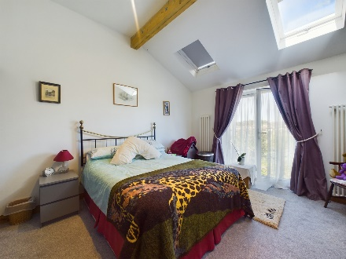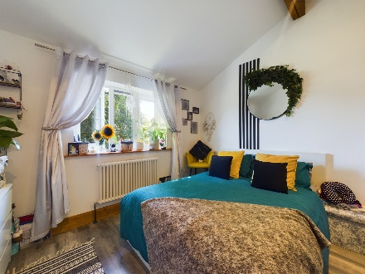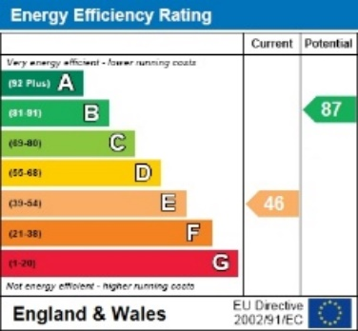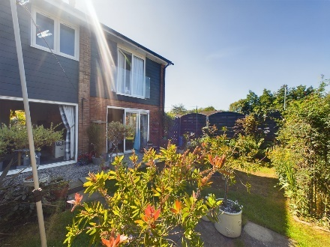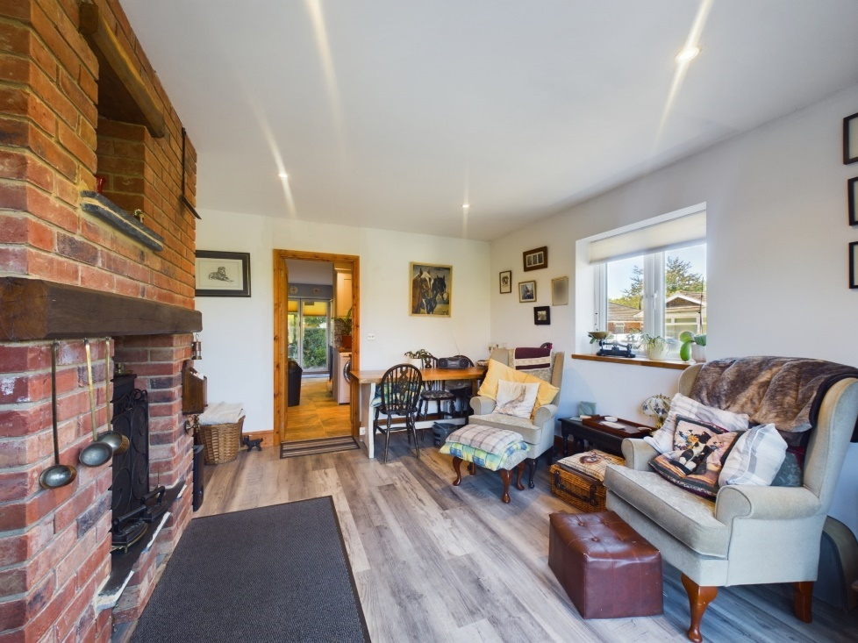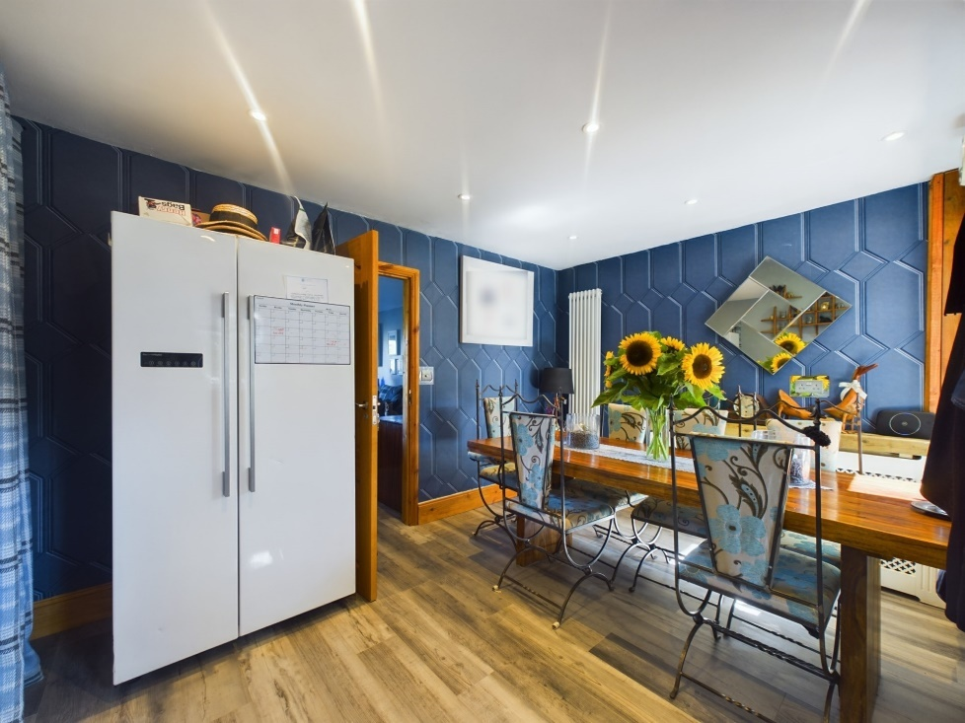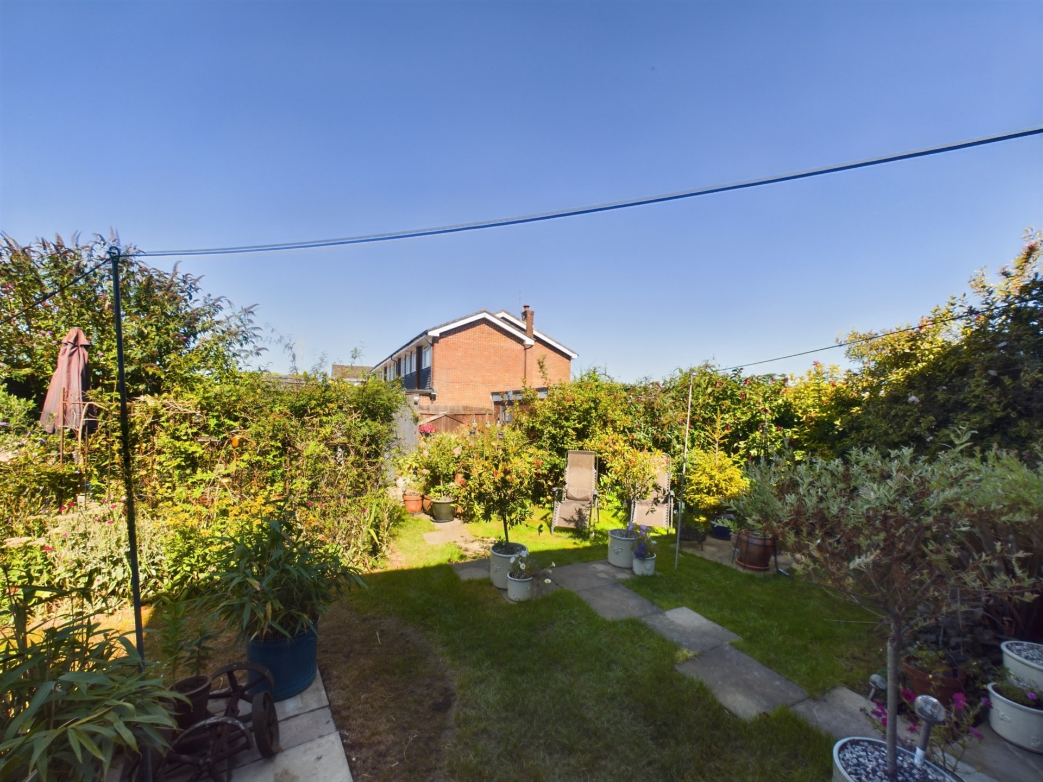

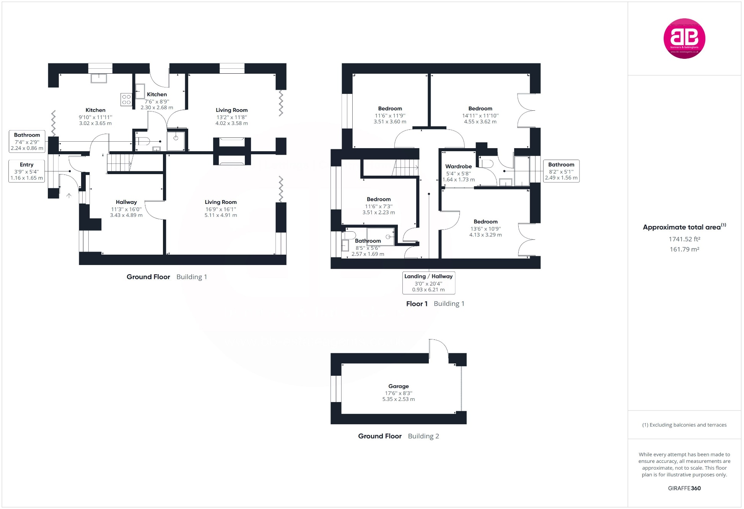

Zoopla LogoNAEA Propertymark Protected CMYKRM_Logo_NoStrap_Colourfacebook logoPrimelocation lscape

**Disclaimer**

We endeavour to make our particulars accurate and reliable. They are for guidance only and are intended to give a fair overall summary of the property. They do not form part of any contract or offer, and should not be relied upon as a statement or representation of fact. Measurements, areas and distances are approximate and photographs provided for guidance only. No undertaking is given as to the structural condition of the property, or any necessary consents, or the operating ability or efficiency of any service, system or appliance. Prospective purchasers must satisfy themselves with regard to each of these points. If there is any particular aspect of the property about which you would like further information, please contact us, especially, before you travel to the property. B2170

1 Karenza, Wycombe Road, Stokenchurch, Buckinghamshire, HP14 3DA

01494 485560

www.bb-estateagents.co.uk