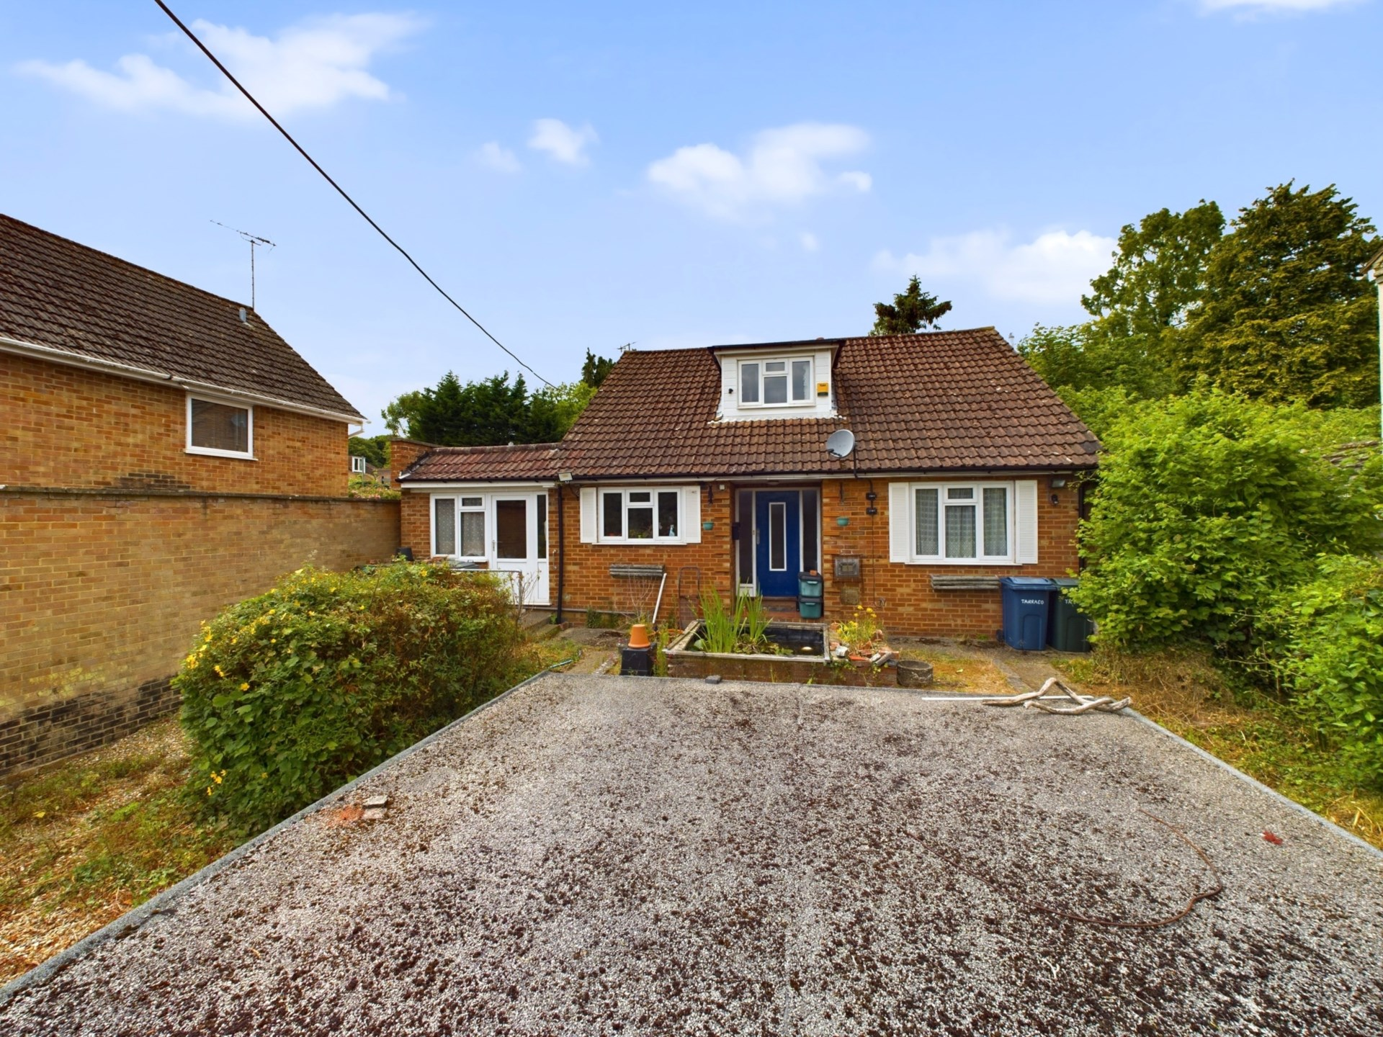



Pinewood Road

Sands

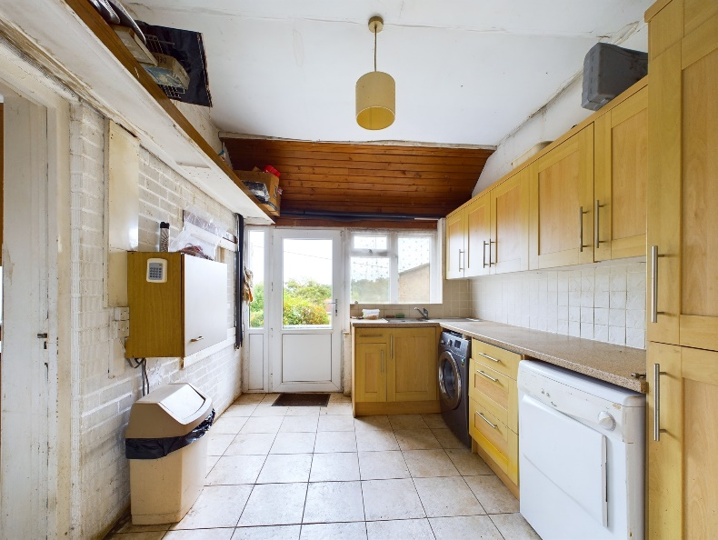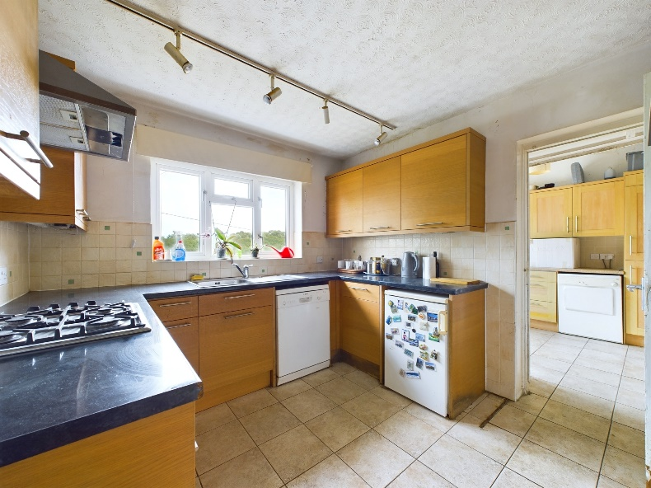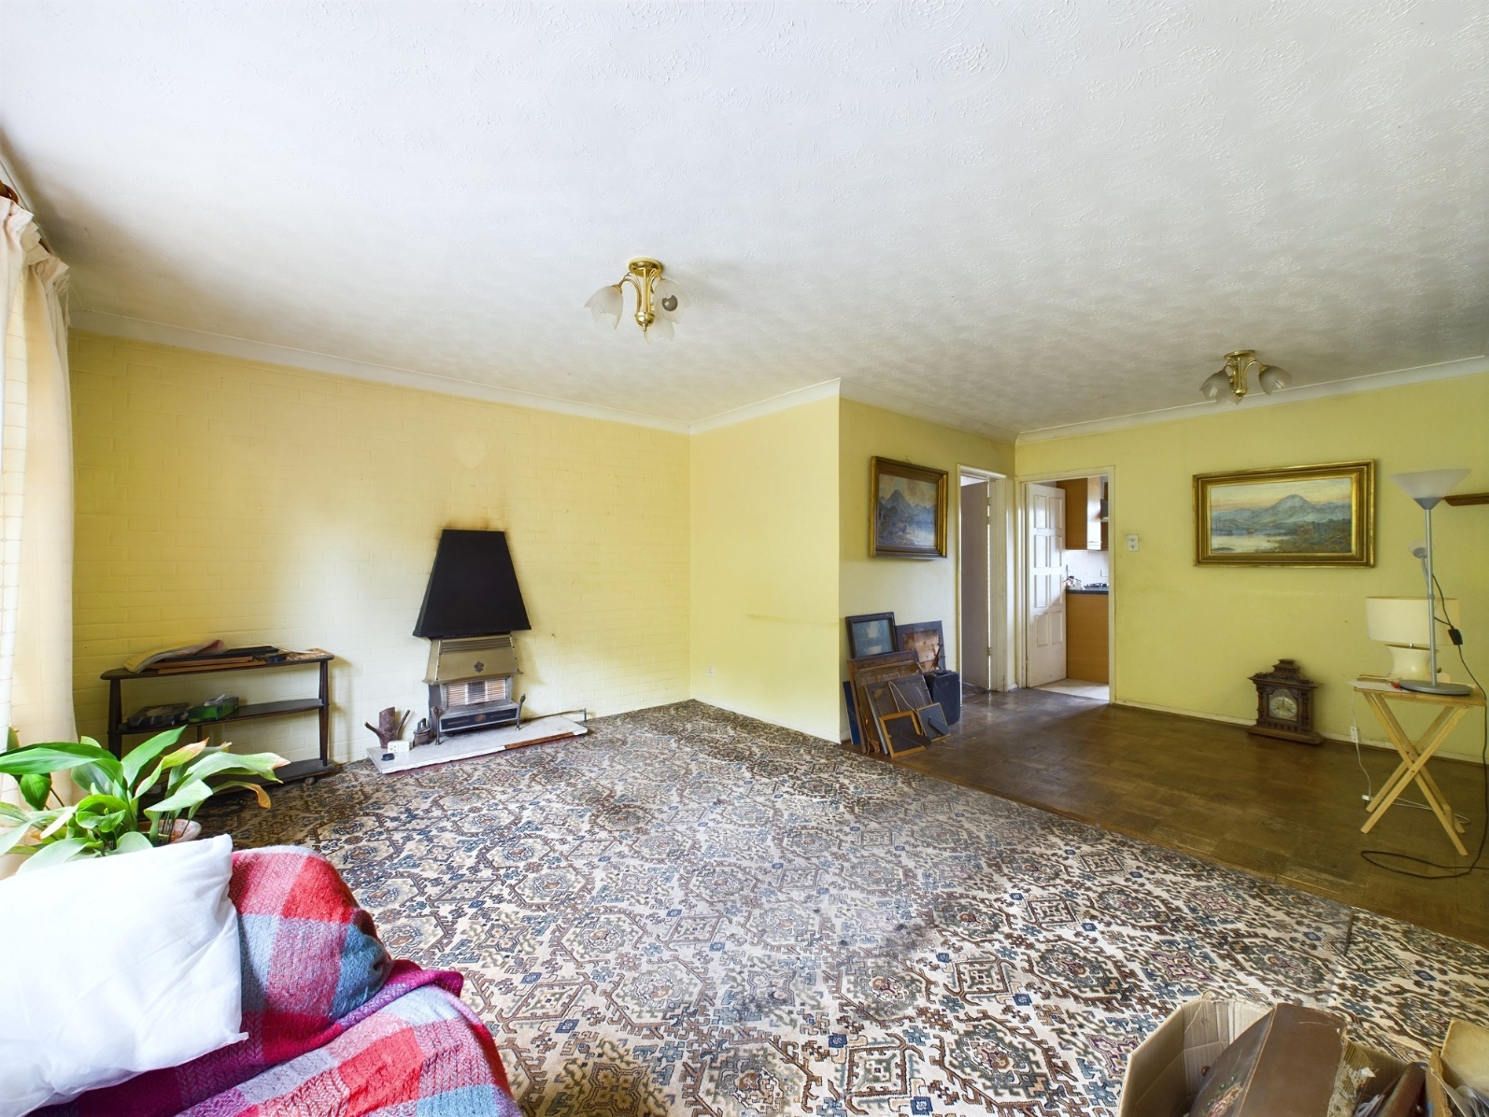

Pinewood Road

Sands

Buckinghamshire

HP12 4DD

£530,000

A five bedroom detached home offering versatile living accommodation with large private rear garden, garage and generous parking. The property is located close to High Wycombe Town Centre benefiting from excellent transport links. The property is in need of some updating and is offered For Sale with NO UPPER CHAIN. Near by, the property benefits from several countryside walks as well as local amenities, schools and great transport links with junction 4 of the M40 a short drive from the property.

The property consists of a spacious living room which provides patio doors to the sunny rear garden, an additional reception room is located next to the living room. The kitchen provides ample eye and waist level storage units, with space for white goods and extends into a separate utility. In addition, there are two double bedrooms and a family bathroom.

Upstairs there are two double bedrooms which provide space for wardrobes and a further single, an additional toilet and ample eaves storage.

Outside there is a good size, rear garden, the garden is bordered by trees and bushes providing privacy. To the front of the property, there is a horseshoe driveway parking for multiple vehicles with a double garage with power.

Other notable features include :

High Wycombe

High Wycombe town centre provides an extensive range of shopping facilities, leisure facilities and restaurants as well as a sports centre and multi-screen cinema complex. Surrounding the town is a selection of golf courses and other recreational amenities too.

For the commuter there is a frequent rail service from High Wycombe to London Marylebone and the area also benefits from being close to the M40, providing links to the national motorway network including the M25 and easy access to Heathrow Airport.

EPC – E

Council Tax Band - E

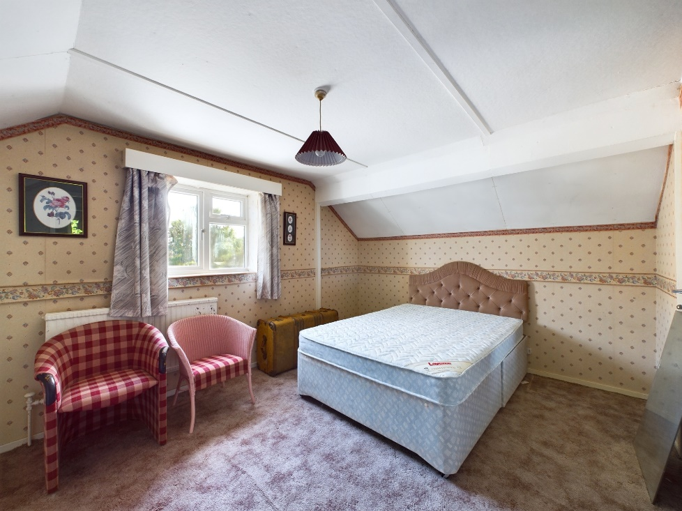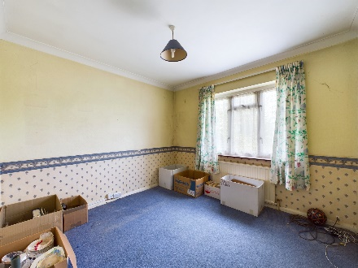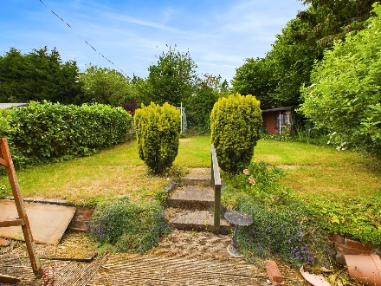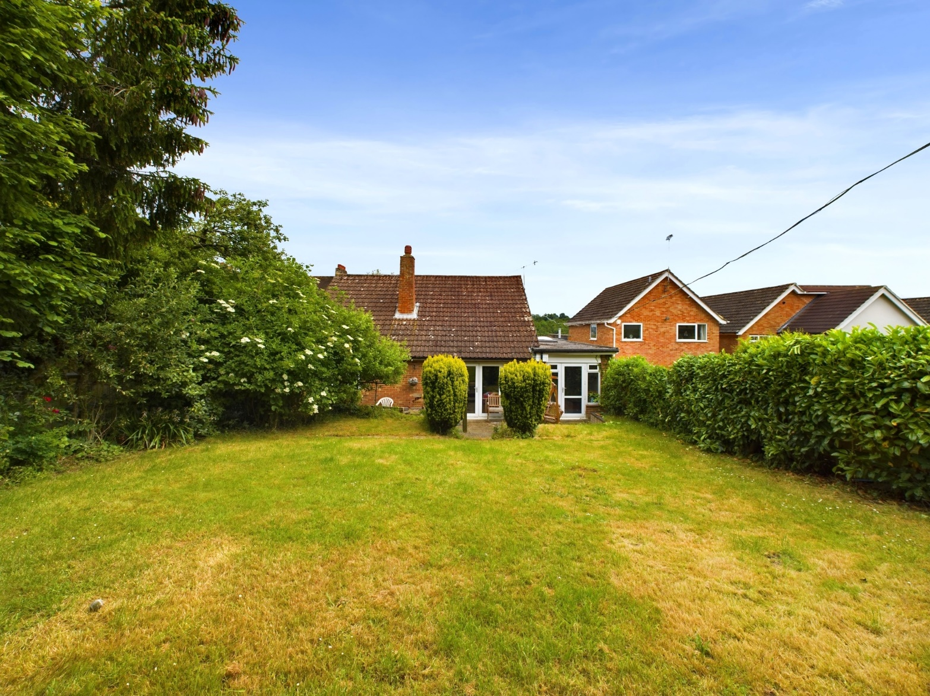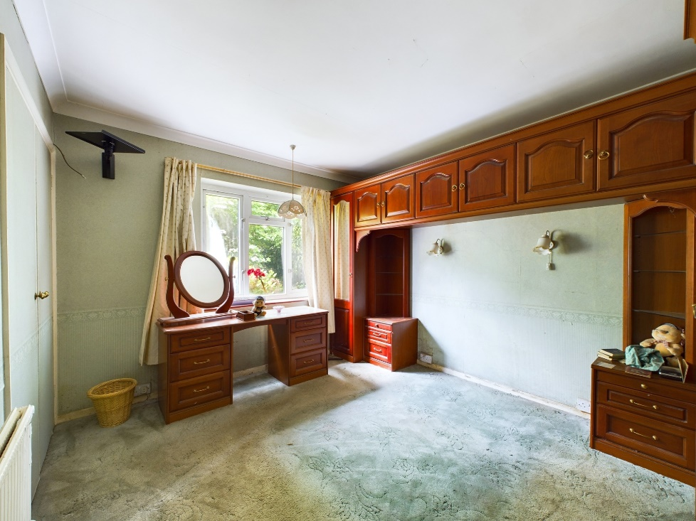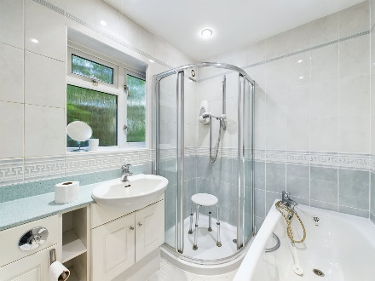

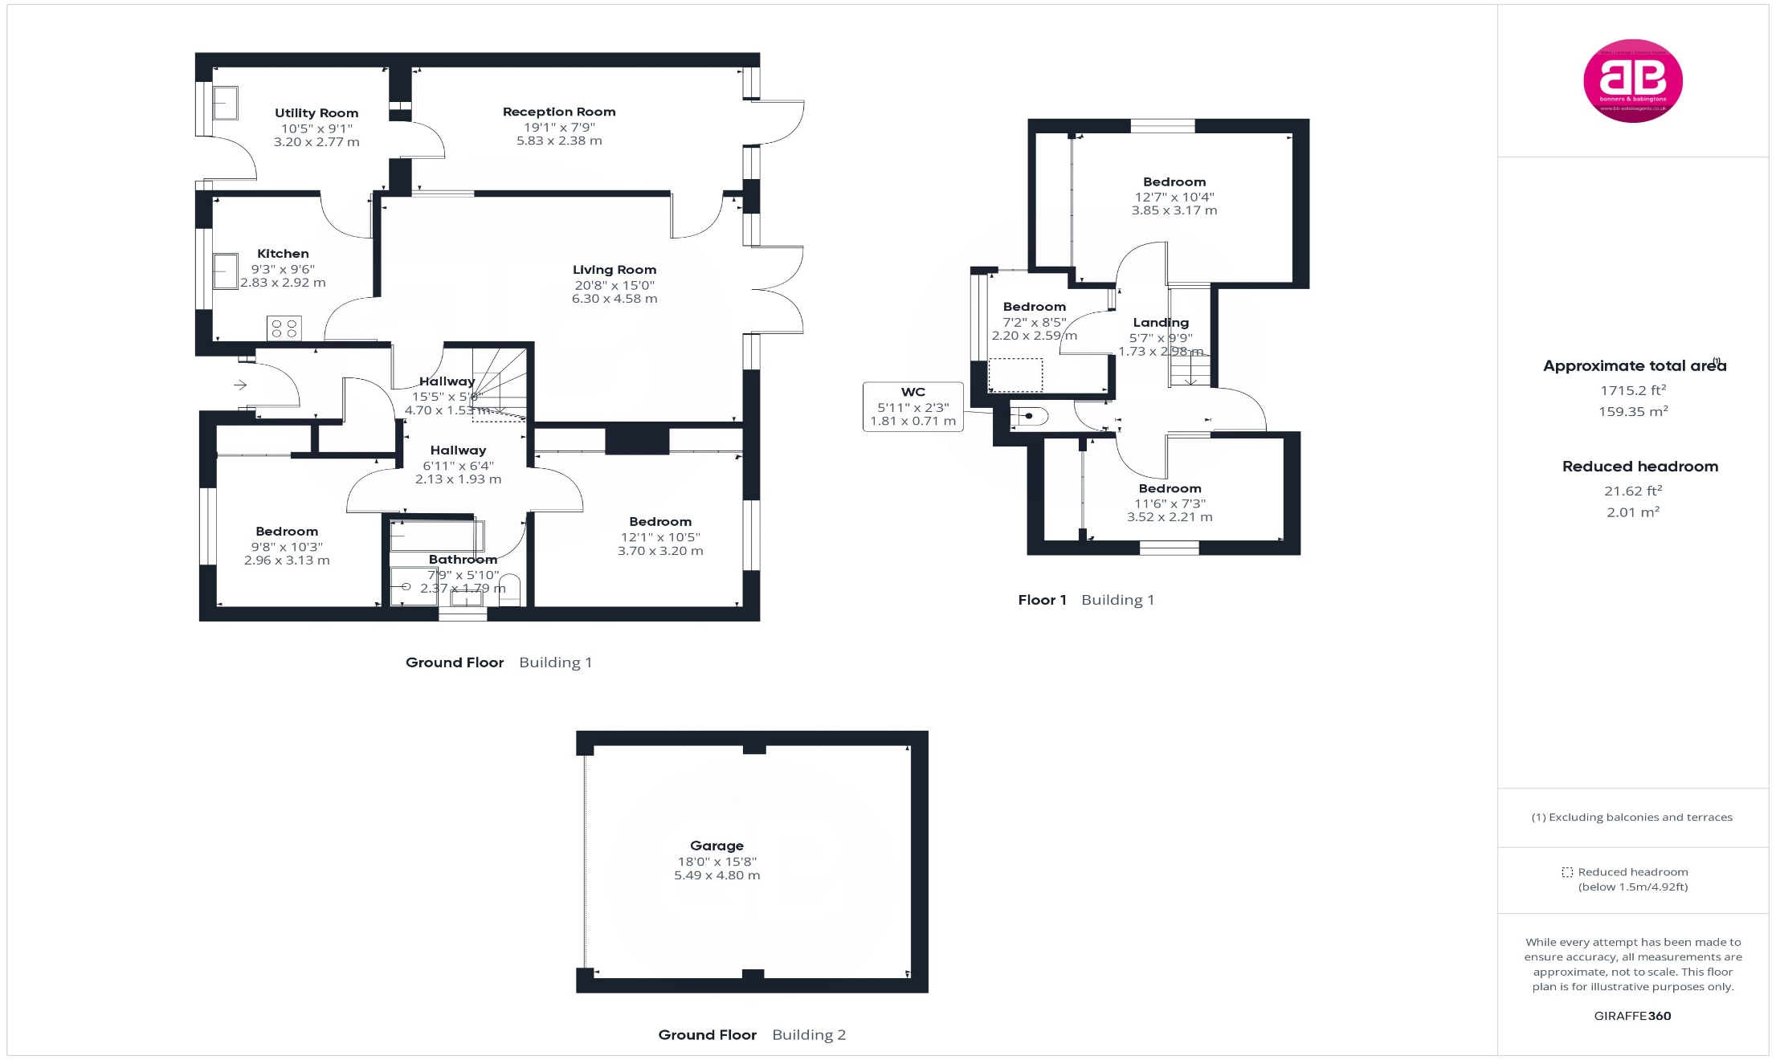

Zoopla LogoNAEA Propertymark Protected CMYKRM_Logo_NoStrap_Colourfacebook logo

**Disclaimer**

We endeavour to make our particulars accurate and reliable. They are for guidance only and are intended to give a fair overall summary of the property. They do not form part of any contract or offer, and should not be relied upon as a statement or representation of fact. Measurements, areas and distances are approximate and photographs provided for guidance only. No undertaking is given as to the structural condition of the property, or any necessary consents, or the operating ability or efficiency of any service, system or appliance. Prospective purchasers must satisfy themselves with regard to each of these points. If there is any particular aspect of the property about which you would like further information, please contact us, especially, before you travel to the property. B2170

1 Karenza, Wycombe Road, Stokenchurch, Buckinghamshire, HP14 3DA

01494 485560

www.bb-estateagents.co.uk