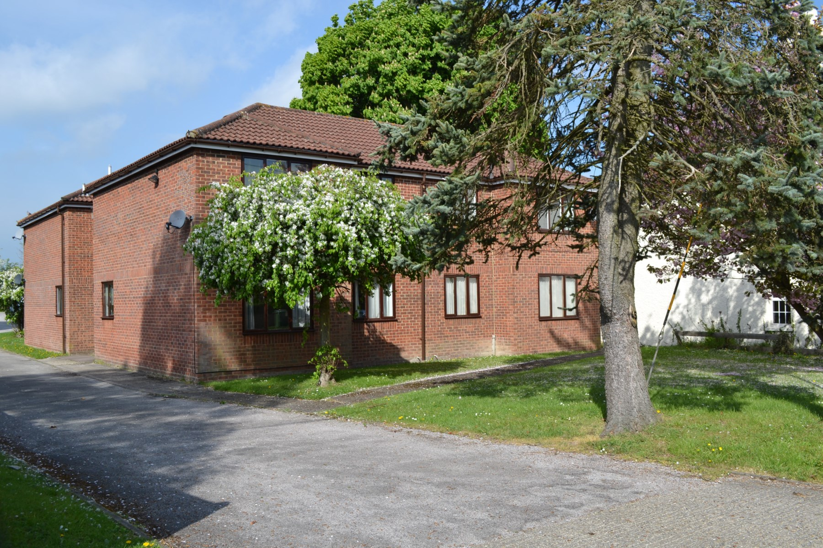bb-logo-final

Summerleys Road

Princes Risborough

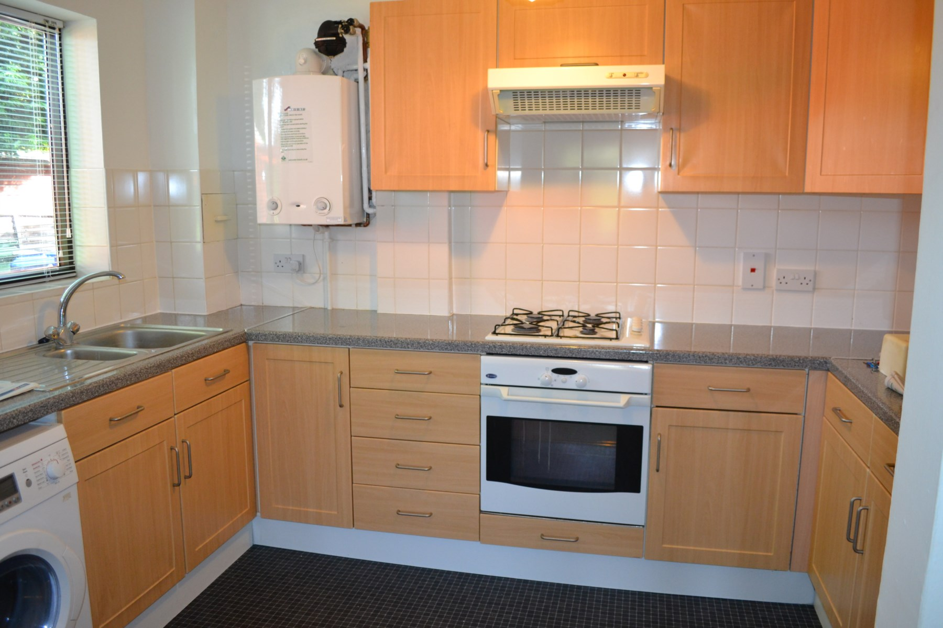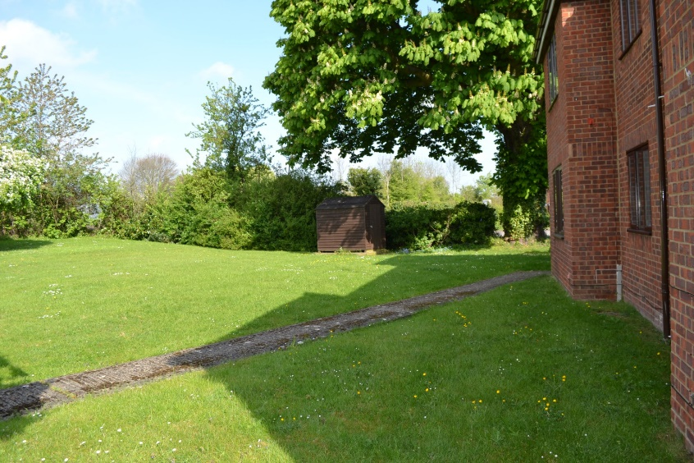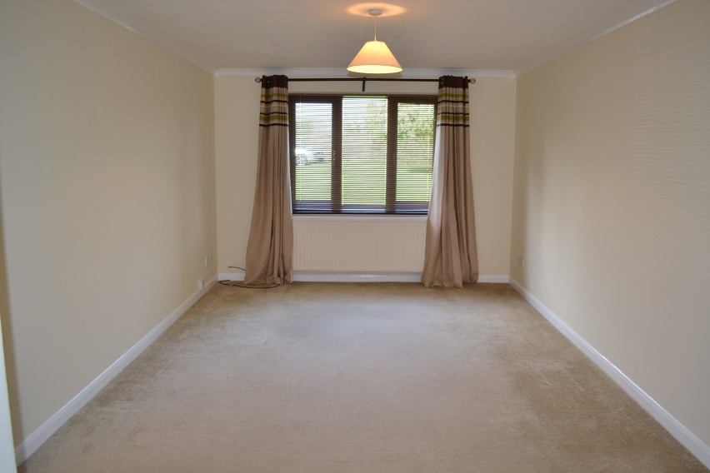

Summerleys Road, Princes Risborough

£850

A one bedroom ground floor apartment which is situated just outside the town centre and within a short walk of the High Street and mainline train station. The property comprises:-

Entrance hall

Kitchen with appliances

Lounge/dining room

Double bedroom

Bathroom with shower over bath

The property also benefits from communal gardens and residents off street parking.

The attractive market town of Princes Risborough offers a post office, a leisure centre and a good range of local shops including a Tesco, Marks & Spencer Simply Food and Costa Coffee. Further, more comprehensive leisure and shopping facilities can be found in High Wycombe, Aylesbury and Oxford all within easy reach. Excellent schooling is provided locally with a good choice of private and state schools close by including grammar schools in High Wycombe and Aylesbury.

There is access to the M40 motorway for London and the Midlands just 6 miles away (J6) and Princes Risborough station offers an excellent main line rail service to London (Marylebone - 35 minutes) and the Midlands.

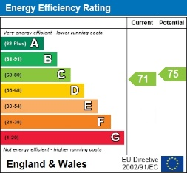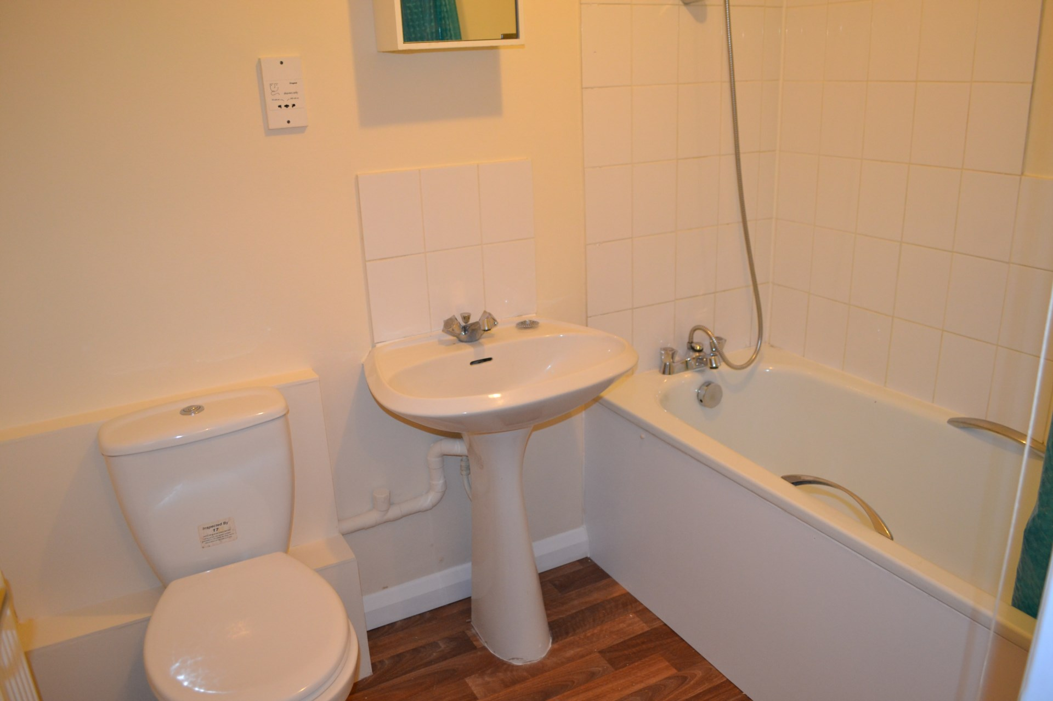

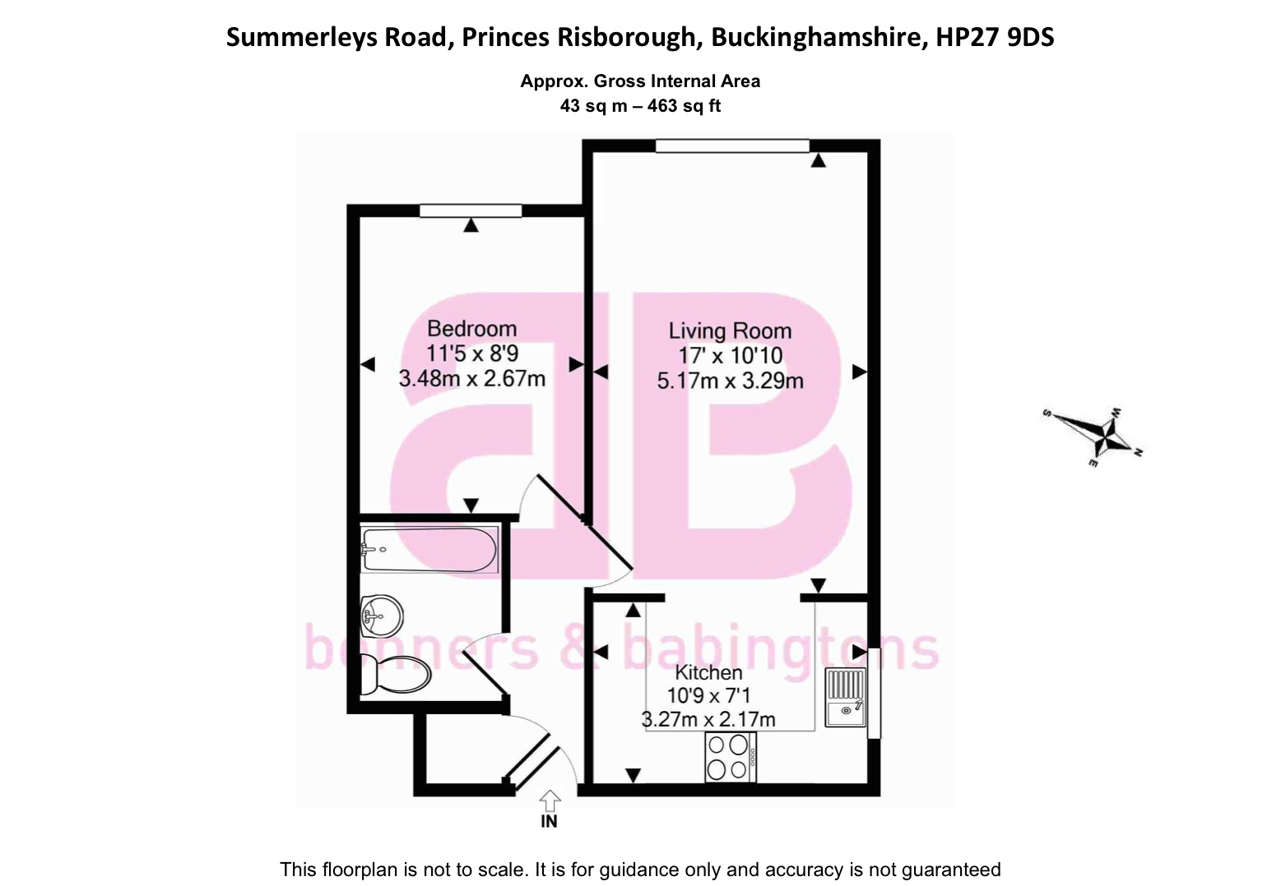

Zoopla LogoNAEA Propertymark Protected CMYKRM_Logo_NoStrap_Colourfacebook logoPrimelocation lscape

**Disclaimer**

We endeavour to make our particulars accurate and reliable. They are for guidance only and are intended to give a fair overall summary of the property. They do not form part of any contract or offer, and should not be relied upon as a statement or representation of fact. Measurements, areas and distances are approximate and photographs provided for guidance only. No undertaking is given as to the structural condition of the property, or any necessary consents, or the operating ability or efficiency of any service, system or appliance. Prospective purchasers must satisfy themselves with regard to each of these points. If there is any particular aspect of the property about which you would like further information, please contact us, especially, before you travel to the property. B2170

Robert House, 19 Station Road,

Chinnor, Oxfordshire OX39 4PU

01844 354554

www.bb-estateagents.co.uk