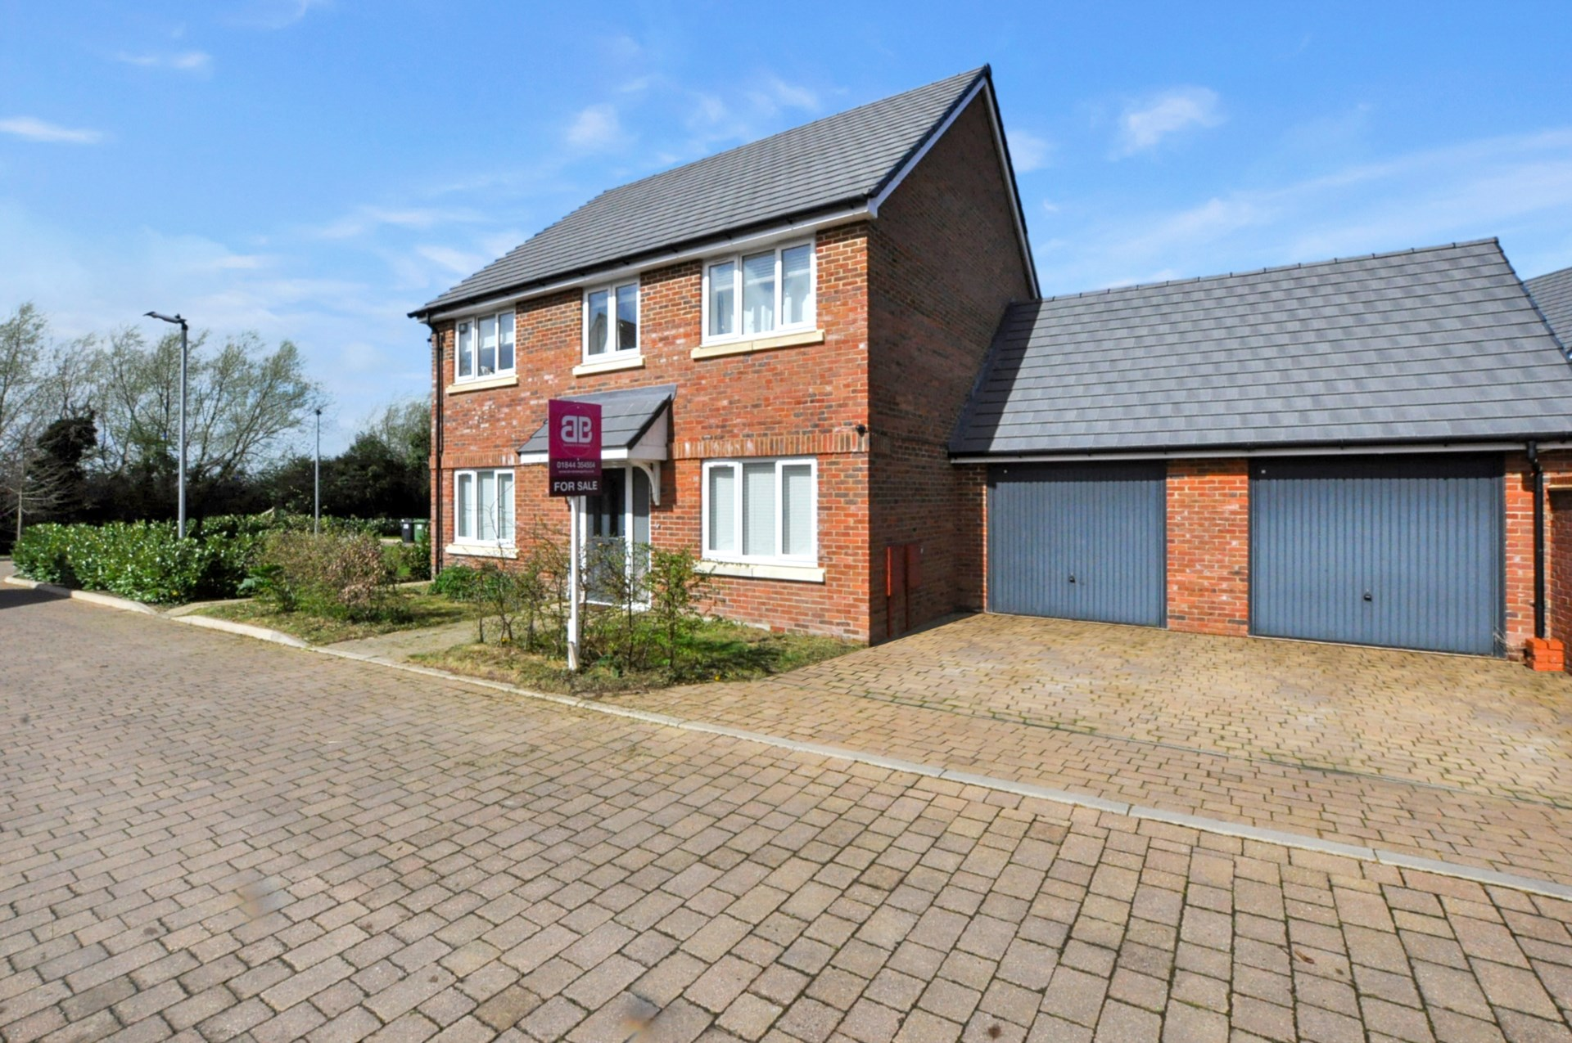bb-logo-final

Pilmore Meadow

Chinnor

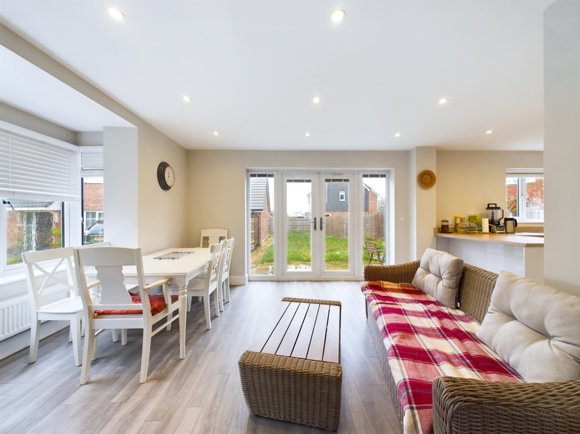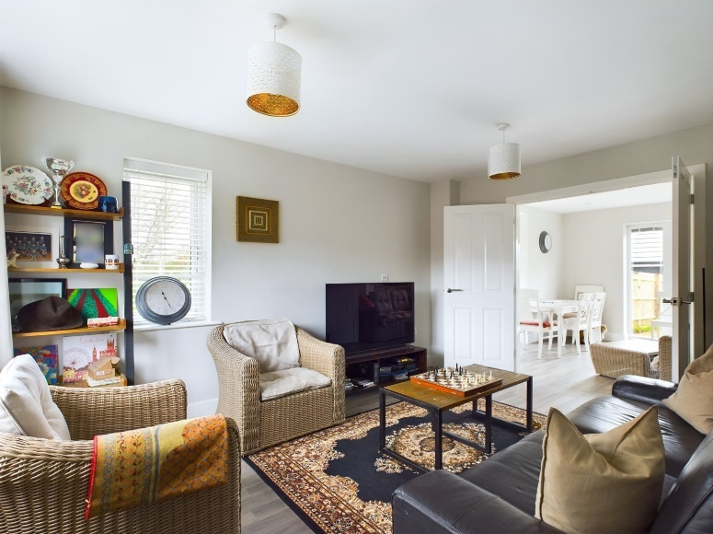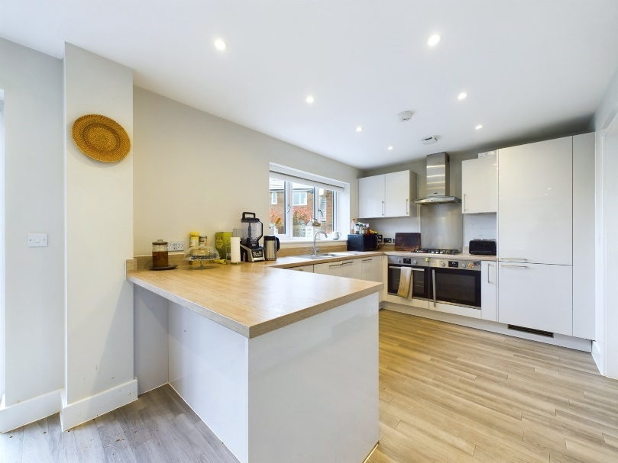

Pilmore Meadow

Chinnor

OX39 4GA

Offers in Excess of : £600,000

A spacious 4 bedroom detached family home with double garage, situated at the end of this quiet development with direct access to the Lower Icknield Way track, offering hours of countryside walks on your doorstep.

The property consists of: entrance hallway with understairs storage for coats and shoes. From the hallway is the main dual aspect reception/family room, that is semi open plan to the spacious kitchen/diner. The dual aspect kitchen really is the heart of the home, whether it be a sociable gathering with friends or for the family to simply gather at the end of a busy day. The kitchen boasts ample eye and waste level units, breakfast bar, integrated dishwasher, fridge/freezer, double ovens and French doors that open out to the garden. There is a separate utility room with plumbing for white goods, further storage and a door to the double garage.

In addition there is a separate snug/office room to the front of the property and a downstairs cloakroom.

Upstairs there are four good size double bedrooms, with the master bedroom boasting fitted wardrobes, ensuite facilities and overlooks the garden and fields beyond. There is also a family bathroom, with bath and overhead rainfall shower, heated towel rail and vanity unit.

**Outside**

The garden is mainly laid to lawn with two sociable patio areas, a blank canvas ready for the next owner to add their mark! There is also a side gate for access.

The property is just steps away from the Lower Icknield Way track, providing the option for lovely countryside walks. Within the development there is also a children`s play area.

The property has a double garage and ample off road parking within its own private driveway.

Location

Situated at the foot of the Chiltern Hills, Chinnor is a popular village conveniently situated on the Oxfordshire/Buckinghamshire borders. Within the village there are good local facilities including a variety of shops, churches, pubs and restaurants, post office, doctor`s surgery, a nursery and two combined schools. Chinnor lies within catchment for the highly regarded Lord Williams`s secondary school in Thame.

M40(Junction 6) is within 3 miles giving access to Oxford(20 miles), High Wycombe(13 miles) and London(48 miles). Princes Risborough mainline station is within 5 miles (Marylebone 35 minutes).

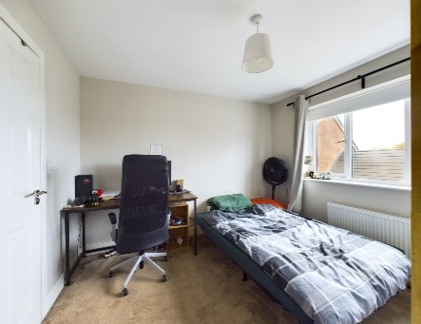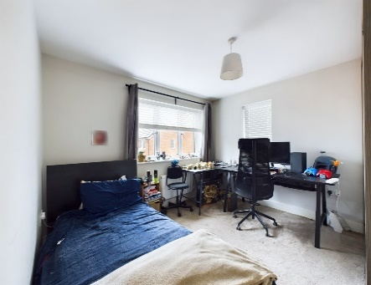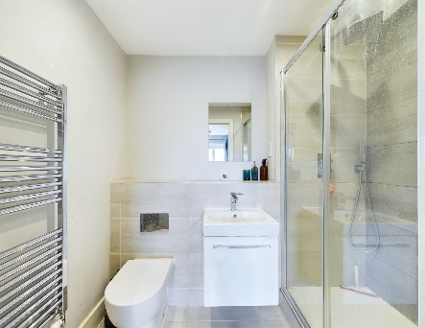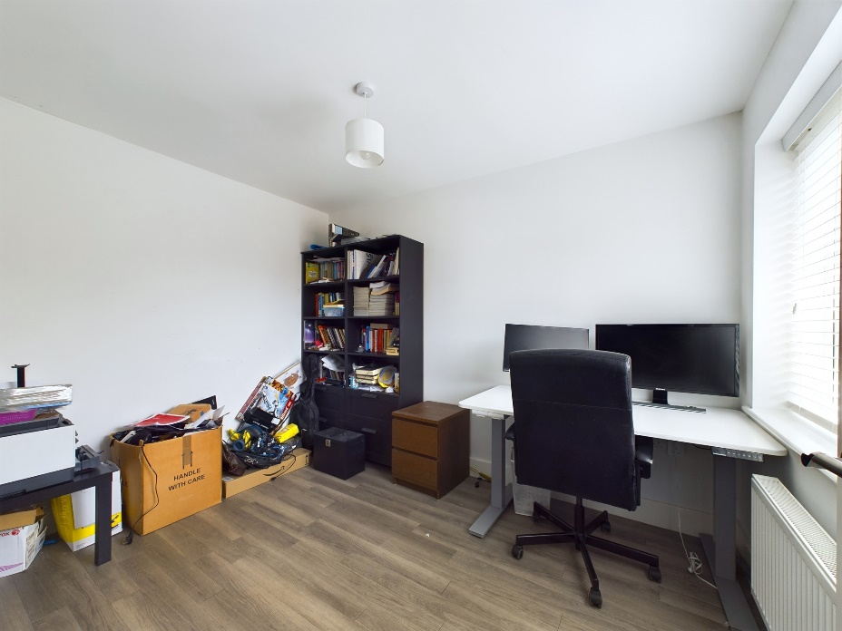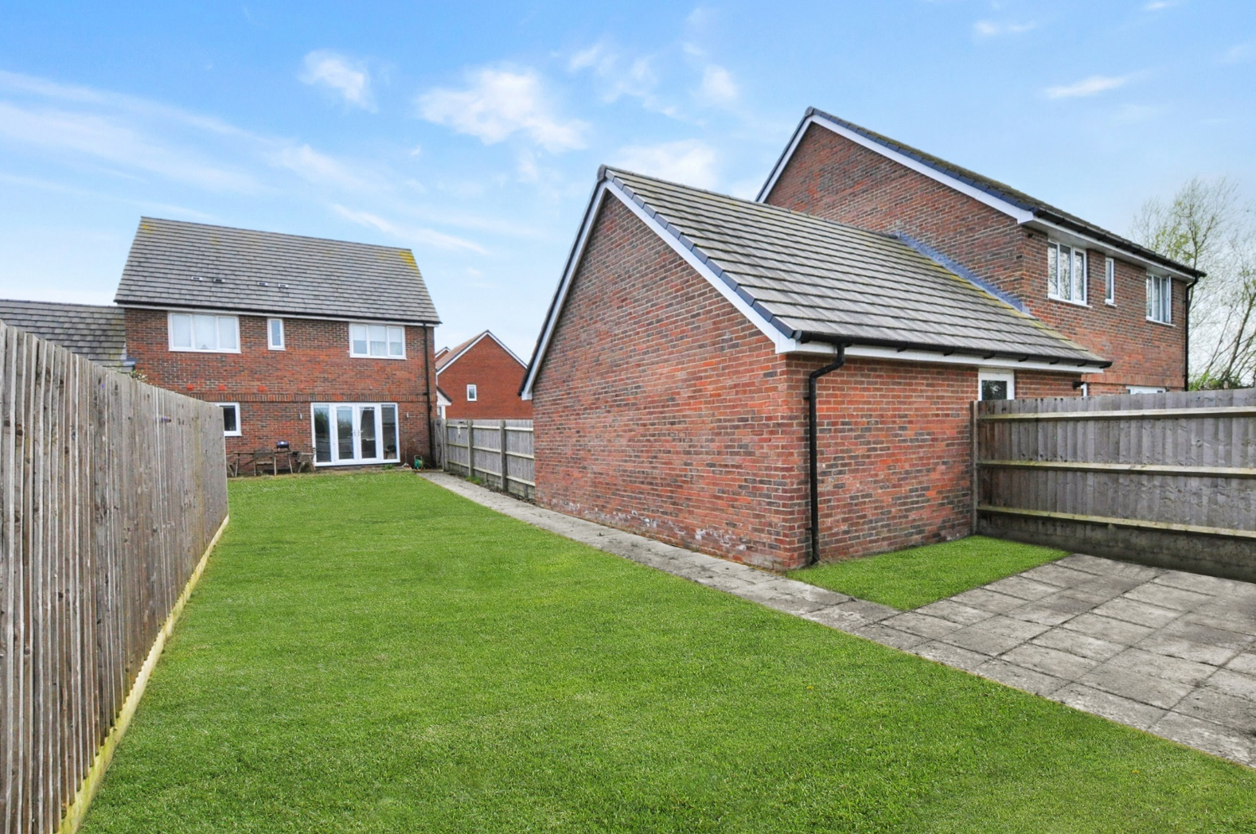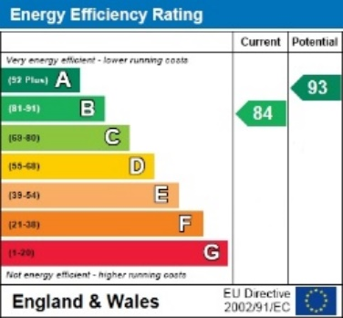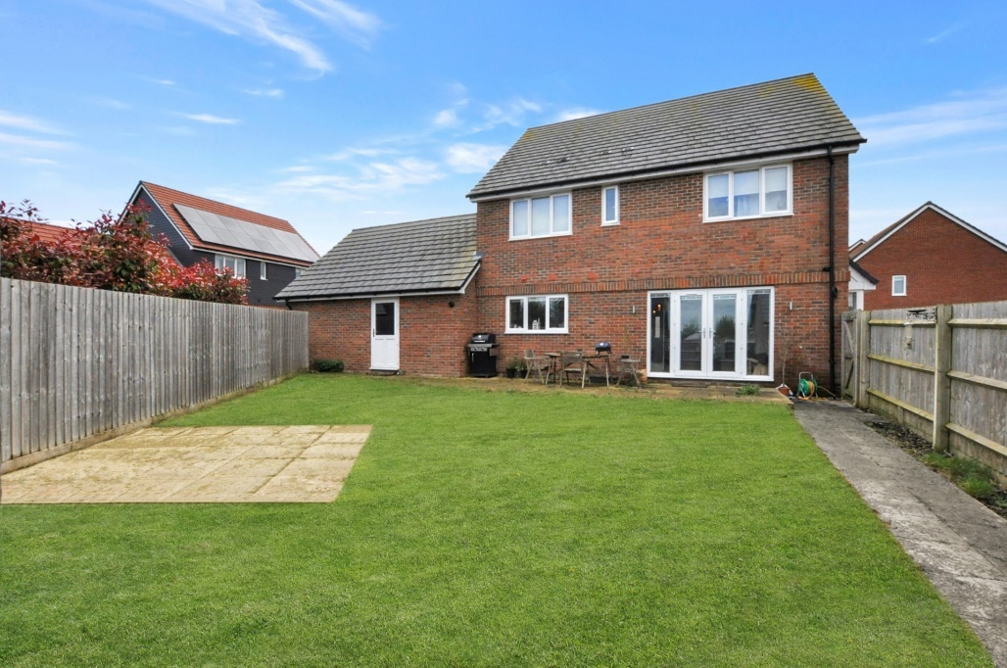

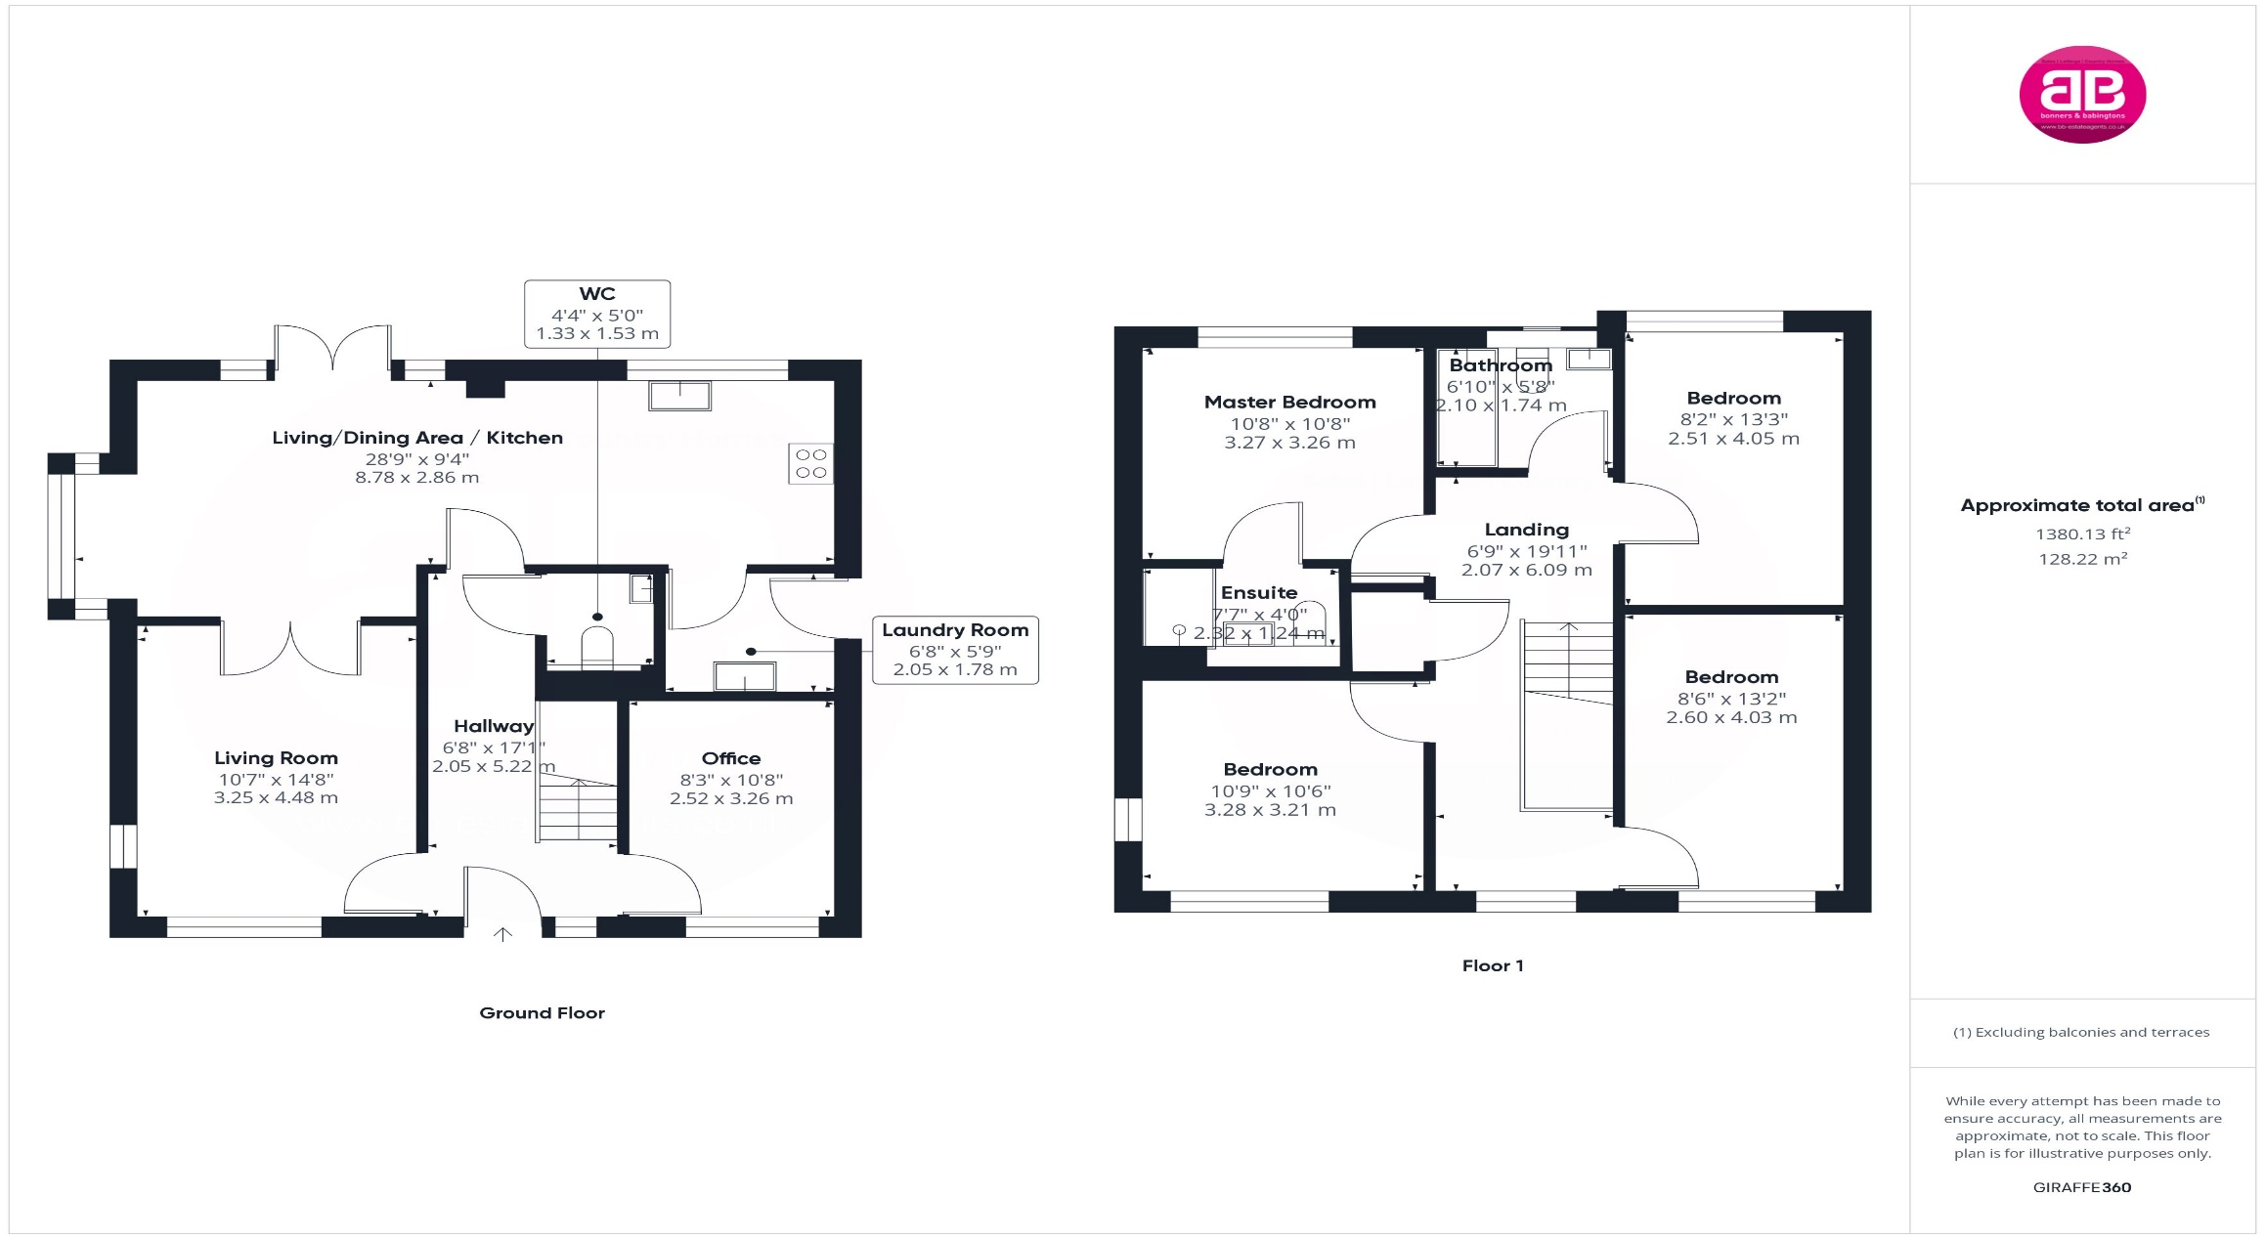

Zoopla LogoNAEA Propertymark Protected CMYKRM_Logo_NoStrap_Colourfacebook logoPrimelocation lscape

**Disclaimer**

We endeavour to make our particulars accurate and reliable. They are for guidance only and are intended to give a fair overall summary of the property. They do not form part of any contract or offer, and should not be relied upon as a statement or representation of fact. Measurements, areas and distances are approximate and photographs provided for guidance only. No undertaking is given as to the structural condition of the property, or any necessary consents, or the operating ability or efficiency of any service, system or appliance. Prospective purchasers must satisfy themselves with regard to each of these points. If there is any particular aspect of the property about which you would like further information, please contact us, especially, before you travel to the property. B2170

Robert House, 19 Station Road,

Chinnor, Oxfordshire OX39 4PU

01844 354554

www.bb-estateagents.co.uk